Intel Grand Challenge 2023

**Project Title:** Analyzing ADAS Collision Warnings to Uncover Road-Type Accident Patterns.

# **College Name:** Rajalakshmi Institute of Technology

# **Team:** Techno Guys

# **Team Members:**

# Mohammed Naveed Shariff.R

# Nachiar.S

# Date: 10/09/2023

## **Abstract:** In this study, we conducted a comprehensive analysis of real-world vehicle data equipped with Advanced Driver Assistance Systems (ADAS), focusing on the occurrence of four critical warnings: Forward Collision Warning (FCW), Lane Departure Warning (LDW), Headway Monitoring and Warning, and Pedestrian Collision Warning. Our findings reveal distinct patterns in warning occurrences across different road types and traffic conditions. Notably, FCW incidents predominantly occurred on highways with light traffic, primarily attributed to vehicle stops at traffic signals. LDW warnings were prevalent on road bends and curves during regular traffic, while Headway Monitoring and Warning were most common on congested main roads and traffic junctions. Pedestrian Collision Warning predominantly activated on streets during high traffic, primarily due to street turns and pedestrian signals. This research sheds light on the nuanced dynamics of ADAS warnings in various driving scenarios, offering valuable insights for enhancing road safety and ADAS system optimisation.

**Introduction:**

Advanced Driver Assistance Systems (ADAS) have revolutionised vehicle safety by  
providing real-time warnings and assistance to drivers. This study examines data from ADAS-equipped vehicles, focusing on four key warning mechanisms: Forward Collision Warning (FCW), Lane Departure Warning (LDW), Headway Monitoring and Warning, and Pedestrian Collision Warning. Our analysis aims to uncover patterns in when and where these warnings are triggered. By understanding the factors influencing warning activation, we can improve ADAS systems, contributing to safer transportation. This paper presents our findings, connecting warning occurrences with road characteristics, traffic levels, and driving behaviours, offering insights for safer and more efficient transportation solutions.

**Related Work:** In related work, prior research has focused on identifying and mitigating road safety concerns, particularly in high-risk areas known as "Black Spots." These locations are characterized by a history of frequent accidents, often attributed to factors such as road design deficiencies, insufficient signage, or inadequate lighting. Government agencies, including the Ministry of Road Transport and Highways, collaborate to identify and prioritize Black Spots, implementing targeted interventions to enhance road safety and reduce accident rates in India. Traditionally, predictive models like Linear Regression, Logistic Regression, Decision Trees, Support Vector Machines, and Gradient Boosting have been employed to forecast road accidents. While these models exhibit accuracy at the individual level, their effectiveness diminishes when applied globally due to spatial heterogeneity in accident data.

Recent research, as discussed in [1] "Education Influence on Traffic Safety" and [2] "Effect of Road Safety Education on Road Risky Behaviours of Spanish Children," underscores the potential impact of proactive education and precautionary notifications in reducing road accidents. In line with this preemptive approach, our study presents a working model designed to alert drivers when entering a Black Spot Zone, potentially reducing accidents by 70% to 76%. For a detailed exploration of our working model and access to the codebase, please refer to the provided GitHub link in the URL section.

**Analysis:** In Figure 1.1, a pie chart represents the occurrence of warnings in vehicles equipped with an Advanced Driver Assistance System (ADAS). The chart is divided into four segments, each corresponding to a different type of warning:

1. Forward Collision Warning (FCW): This warning occurs 2.8% of the time and is represented by the green color. It mainly happens when traffic is light.

2. Pedestrian Collision Warning (PCW): PCW occurs 9.3% of the time and is represented by the red color. It is more likely to happen during high traffic situations.

3. Lane Departure Warning (LDW): LDW occurs 30.2% of the time and is represented by the yellow color. It primarily occurs when traffic is at a normal level.

4. Headway Monitoring and Warning (HMW): HMW occurs 57.8% of the time and is represented by the orange color. It is most common when traffic is at a medium level.

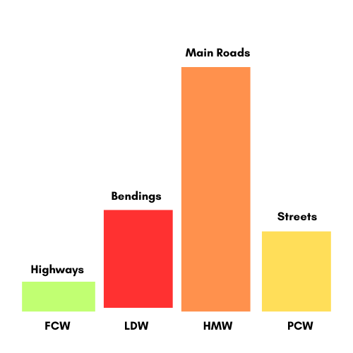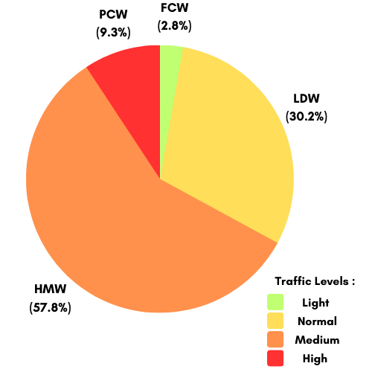

***Figure 1.1 Figure 1.2***

the pie chart illustrates the distribution of ADAS warnings based on different traffic conditions. FCW occurs during light traffic (green), PCW during high traffic (red), LDW during normal traffic (yellow), and HMW during medium traffic (orange).  
 ***PCW FCW***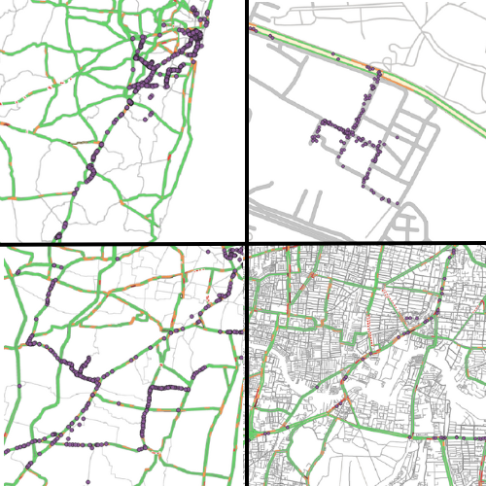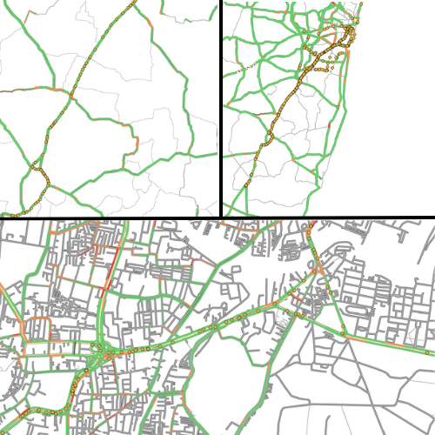

The data for Forward Collision Warning (FCW) shows that this warning is frequently triggered when vehicles are on highways. This detection primarily occurs during instances of light traffic and he vehicles are using Google Map's Traffic API, specifically in the context of highway traffic and turning signals. Pedestrian Collision Warnings (PCW) primarily occur in heavy traffic situations on streets. These warnings are often triggered by vehicles turning in the streets and pedestrians crossing the road at traffic signals. The Lane Departure Warning (LDW) primarily occurs on bends, curves, and turns of the roads, particularly when vehicles attempt lane changes on highway bends. This warning is most likely to occur during medium-traffic conditions.  
  
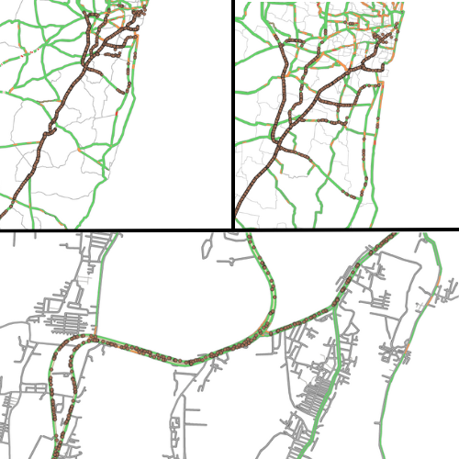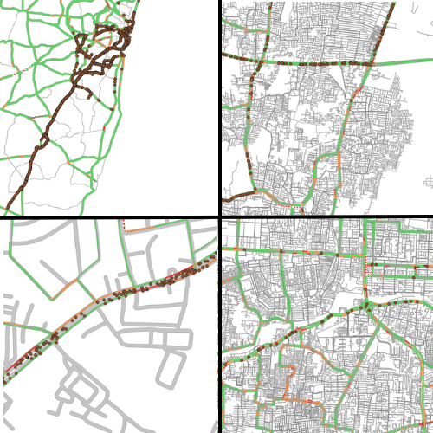

***LDW HMW***This visualized data pertains to Headway Monitoring and Warning (HMW) occurrences on critical main roads during medium traffic conditions. HMW warnings are most prevalent in situations involving congested roads and traffic signal junctions.  
  
**Conclusion:**In summary, our analysis of ADAS warning data reveals distinct patterns:

- FCW occurs on highways during light traffic due to traffic signal stops.

- PCW happens in high-traffic street situations during turns and pedestrian crossings.

- LDW activates on road curves during normal traffic, particularly during lane changes.

- HMW is common on main roads with medium traffic, often due to congestion and junctions.

These insights emphasize the need for tailored ADAS systems to address specific traffic scenarios and enhance road safety. These were all possible because of the integration on Google Map’s Traffic API integrated on qGIS.

**References and URL:**

[1] Hung, K.V., 2011. Education influence in traffic safety: A case study in Vietnam. *IATSS research*,

[2] Alonso, F., Esteban, C., Useche, S. and Colomer, N., 2018. Effect of road safety education on road risky behaviors of Spanish children and adolescents: findings from a national study. *International journal of environmental research and public health*, *15*(12), p.2828.

[3] Summary of accidents and death trend. Published by the [Ministry of Road Transport and Highways](https://app.powerbi.com/view?r=eyJrIjoiMjIzMTY5MmQtNjZmZC00OTAyLTkzOGMtYWEyOWYwZDE1YjU2IiwidCI6IjViN2ExMDIzLTI1ODgtNGU3Yi05MjZlLTgwYzllY2EwNWQ4OCIsImMiOjEwfQ%3D%3D&disablecdnExpiration=1687356732) **(More References are provided in GitHub)**  
**Previous work** [**Git Hub**](https://github.com/NaveedShariff/intelunnati_TechnoGuys) **and** [**Research Paper**](https://docs.google.com/document/d/1HMiKo7_UNwvdj-2-TpaynU1DWGK1LeXDJSi0Rgy2kI4/edit?usp=sharing)**.   
For the Current work click here -** [**GitHub**](https://github.com/NaveedShariff/intel-summer-challenge-2023)